Subject: 45th Anniversary Reunion OCS Portsea Dec 1973 Graduating Class – Update 22 Nov 17.
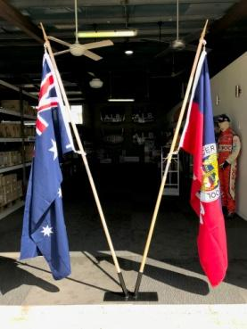
Dear Classmates,
This is the final update for this year. As you will see almost all arrangements are complete. There is still some work required by both the organizing team and yourselves.
Program
Friday 7 December 2018 – Meet & Greet - Dress Code: Smart Casual

The selected venue is The Pool Terrace – Level 8 Poolside – Hilton Brisbane. Buckie with Rick and Sue Lanham inspected the site and report that it is an excellent venue. While the pool area will be open to house guests our area will be cordoned off and a PAYG BAR will be in operation. Due to Qld licensing/liquor law, venues hosting functions such as this are required to serve substantial food. Quote from Hilton. Estimated cost is approx. $50 per head. The Organising Team has secured a sponsor to defray this cost to the value of $30 per head which means that those attending need pay only $20 per head plus drinks (PAYG). Background music may be played via USB – Buckie has organized a USB with the “Top 100 Hits From 1973”.
Timings listed : Setup 18:00 – 19:00, Reception 19:00 – 22:00, Teardown 22:00 – 23:00. For those attending the meet & greet Buckie will have their memorabilia available. See below for more detail on memorabilia.

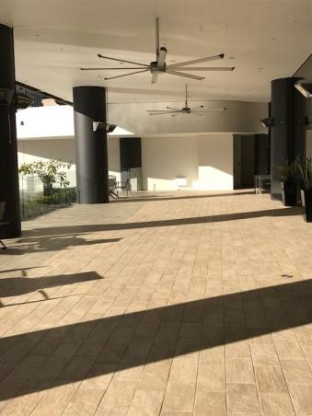

Saturday 8 December 2018 – Late Morning Memorial Service – King George’s Square – Dress Code: TBA when arrangements complete.
It is confirmed that Padre Peter Devenish-Meares will be available for a short service at Anzac Square. Mark Gallagher is liaising with the Padre and Brisbane City Council to develop the format and this will be advised to all when confirmed. Broad outline is assemble, service starts 1100 hrs and concludes NLT 1130 hrs. The Padre will also attend the Friday night Meet and Greet to get to know us and prep himself for the following day.

Saturday 8 December 2018 – Kookaburra Showboat Cruise – Dress Code: Smart Casual
“STRICTLY NO SMOKING AT ALL ON THE VESSEL”

Buckie has done the recon of the facilities on board “KOOKABURRA QUEEN 11”. We have booked the bottom deck which covers all requirements for disability access and toilets.
Buckie has paid the deposit of $1,100. We have accepted the Gold Buffet & Gold Drinks Package with the extra hour in dock after the cruise.
- Food: Buffet Menu – Follow this link: However as we are some way out from the function there may be some menu variations but as we have booked early there will be no price changes.
- Drinks: Hahn Light, Great Northern, Hahn Super Dry, XXXX Gold, Crown, Heineken, choice of two white wines, choice of red wine, choice of sparkling wine, soft drinks. Spirits are PAYG
- The walk from the Hilton where Buckie stayed to the Eagle Street Dock was 5-10 minutes.
- Timings: 18:30 Boarding - 19:00 Safety Briefing & Departure – 19:10 Buffet Open – 21:00 Buffet Closed – 22:00 Return to Dock – 23:00 Event Conclusion.
- An accommodation offer is also provided that may be of some use to those attending. Follow this link for further info.
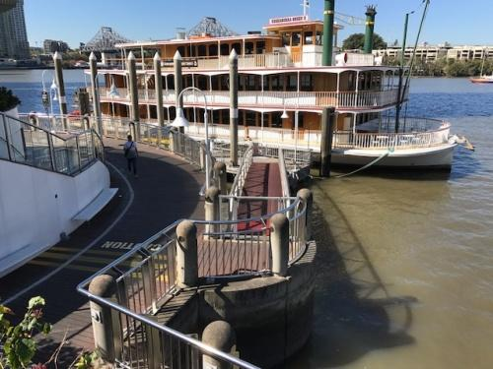

Sunday 9 December 2018 – Recovery Luncheon Royal Queensland Yacht Squadron – Manly – Dress Code: Smart Casual

If you are not aware, Mark Gallagher is the Commodore of the RQYS so we can be assured of excellent facilities and service. Buckie has completed the recce, the venue & views superb, staff excellent and the food sensational, a first class venue that will offer Graduates & Partners who attend two options;
- Boardwalk Cafe & RQ Bar
- The Squadron Harbour View Restaurant
- Address: 578 Royal Esplanade Manly Qld 4179, Tel: 07 3396 8666
- All that need to be done is know how many are attending and to to set an RV time? PAYG food & drinks.

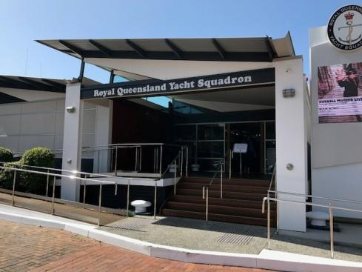

Memorabilia:

All memorabilia is now completed and in hand, cost of per pack is $50 to be added to the Graduate cost for the Saturday night.

All graduates receive one of each of the following:
- Presentation Bag
- Cap
- Pen
- Beer Mug
- Stubbie Holder

Additional items are available for purchase at the following prices:
- Cap: $25.00
- Pen: $5.00
- Beer Mug: $30.00
- Stubbie Holder: $8.00

If interested you need to advise Buckie so he can bring the extras.

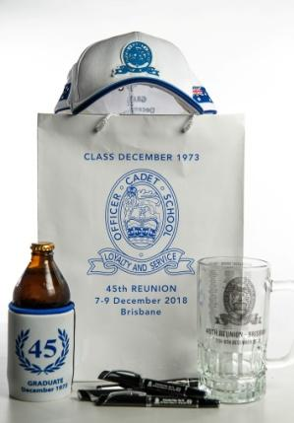

Cost Summary

- Friday Night - $20 per head plus PAYG drinks
- Saturday – Kookaburra Cruise:
  - Graduate $210-00 (Includes $50 Memorabilia package) Partner $160.
    - Calculations based on 50 PAX:
    - Graduate - Food: $96.60, Beverage: $43.05, Extra Hour: $20.00, Memorabilia $50.00 = $210.00/person.
    - Partner - Food: $96.60, Beverage: $43.05, Extra Hour: $20.00 = $160.00/person.
- Sunday Lunch RQYS – PAYG.

Who Is Coming?

Attached is the spreadsheet – Attendance Summary. Those highlighted in green have responded to previous emails. Where there is a number on Columns G & H the classmate has said they planned to attend with or without wife/partner. So, if your name is not in the green, we would appreciate a response, Yes/No/Maybe. Please email to Feens at isaanalex@gmail.com. No need to Reply All.

Payment.

If the 40th Reunion was any guide, we would prefer not handling cash on the night as we too will, quite possibly, imbibe in some liquid refreshments hence we would appreciate prepayment for the:
- Hilton Meet and Greet - $20/head
- Kookaburra Cruise – Graduates: $210/head, Wives/Partners: $160/head

We will use a Commonwealth Bank account and disburse monies from there to Buckie for deposits already paid and the memorabilia, Hilton Hotel for the Meet and Greet, and Kookaburra Cruises for the Saturday night.

Our Reunion Bank Acct details are as follows:
- Bank: Commonwealth Bank
- BSB: 064-192
- SWIFT Code: CTBAAU2S
- Acct Name: OCS REUNION
- Acct Number: 1006 4320
Please email Mark and Eric with the details of your transfer.

Cut-off Date.

The cut-off date for confirmed attendance and payment is 1 July 2018. No refunds can be paid after 16 Nov 2018.

Conclusion.

The next meeting for the organising team is early February and you will receive a further update after that meeting.

On behalf of Buckie, JD, Mark, Rick and myself, we wish you and your families a merry and safe Christmas and a prosperous and happy New Year.

Rgds

Feens

